|  |  |  |
| --- | --- | --- |
| **Report IDM reference No.** | *EFDA_D_2MFY5M* | **Version: see IDM** |

Final Report

on Deliverable

*MAT-1.3.1-T3-D1 Status Report on Development of Rules for Brittle Fracture (KIT)*

|  |  |  |  |
| --- | --- | --- | --- |
|  | | **Deliverable-ID**[1] | *MAT-1.3.1-T3-D1* |
| **Work Package** | *WPMAT* | **Date** | *31.Oct. 2016* |
| **Project Leader** | *Michael Rieth* | | |
|  | | | |
| **TS Title** | *EDDI Structural Design Criteria – Priority Gaps – Brittle Fracture* | | |
| **TS Ref. No.** | *EDDI-1.3.1-T03* | **TS IDM-link** | *EFDA_D_2KXPEY* |
| **Task Owner** | *Marco Conte* | | |
| **RU(s)** | *KIT* | | |

|  |  |
| --- | --- |
| **Report Review & Approval** | |
| **IDM role** | **Name(s)** |
| **Author** | *Marco Conte* |
| **Co-author(s)** | *Jarir Aktaa* |
| **Reviewer(s)** | *Manminder Kalsey, Mike Gorley* |
| **PMU Reviewer** | *Eberhard Diegele* |
| **Approver** | *Michael Rieth* |

|  |  |  |  |  |  |
| --- | --- | --- | --- | --- | --- |
| x | Study / Assessment |  | Procurement / Commissioning of Hardware |  | Industry |

|  |  |  |  |
| --- | --- | --- | --- |
|  | Use of Facility |  | Other *{please specify}* |

|  |
| --- |
| **Executive Summary** |
| Complementary fracture mechanical experiments as well as bending tests supporting modelling of the observed fracture behaviour of tungsten alloys particularly in the brittle regime have been elaborated and described. In addition a short overview and results of the numerical simulation of crack propagation using the Cohesive Zone Model has been given. |

|  |
| --- |
| **Comments** (shortcomings, deviations, etc.) |
|  |

**Table of Contents**

1 Short Introduction and Objectives of Work 4

2 Description of Work 5

2.1 Experiments 5

2.1.1 Fracture mechanical (FM) test 5

2.1.2 Bending test 6

2.2 Results 7

2.2.1 Bending stress 7

2.2.2 Fracture toughness 9

2.2.3 Fracture surface analysis 11

2.3 FEM – Cohesive Zone Elements 12

2.3.1 Elastic Properties and Cohesive Zone Parameters 12

2.3.2 2d 3PB Model 12

2.3.3 3d 4PB model 14

3 Irradiation experiments 15

4 Conclusion and Outlook 16

4.1 Conclusion 16

4.2 Outlook 17

5 References 18

**Abbreviations**

|  |  |
| --- | --- |
| DEMO | DEMOnstration Power Plant |
| W | tungsten |
| WL10 | tungsten with 1wt. % La2O3 |
| CuCrZr | chromium Zirconium Copper Alloys |
| Eurofer | reduced activation ferritic-martensitic steel |
| 3PB / 4PB | three-point bending test / Four-point bending test |
| DBTT | ductile-brittle-transition-temperature |
| EDM | Electrical discharge machining |
| FM | fracture mechanical |
| SENB | Single Edge Notched Bend |
| CZE | Cohesive Zone Element |
|  | flexural strength (MPa) |
|  | maximum force (N) |
| εf | flexural strain (-) |
| E | Young`s modulus (GPa) |
| µ | Poisson`s ratio |
| w | height (mm) |
| b | width (mm) |
| l | length (mm) |
|  | initial crack length (mm) |
|  | inner and outer span of 4PB fixture |
| S | span of 3PB fixture |
|  | critical stress intensity factor (Mode I) |
|  | calculate stress intensity factor |
|  | maximum stress intensity factor |
| 2d / 3d | two dimensional / three dimensional |

# Short Introduction and Objectives of Work

One of the priority gaps that has been identified is Brittle Fracture Rules for components operating in the brittle regime (e.g. Tungsten, or irradiated CuCrZr & Eurofer). Current rules have been identified as being overly conservative and hence provide an unnecessarily small design space for components using this material [1]. As a result of this identified gap, work has commenced to introduce appropriate design rules that provide an acceptable level of conservatism in the brittle regime. Although this task initially focused on Tungsten, this task now covers all three DEMO baseline materials (W, CuCrZr, Eurofer) in both irradiated and unirradiated states.

Work was initiated in 2014 and shall continue to progress in 2016 with the following tasks:

* Performing and evaluating of complementary fracture mechanical experiments as well as tests supporting modelling of the observed fracture behaviour particularly in the brittle regime.
* Progress the development of a suitable damage model for describing and simulating the fracture process observed in fracture mechanical tests considering specific aspects, e.g. anisotropy.
* First draft on the elastic-plastic Brittle Fracture rule for DDC.
* Propose proper irradiation experiments on EUROFUSION baseline materials (e.g. from CuCrZr, EUROFER97, W/W alloys) for taking irradiation effects into account.

# Description of Work

A description and introduction of this work has been given in the previous reports [2]. Furthermore the used material, crack growth modelling with Cohesive Zone Elements (CZE) as well as the probabilistic approach has been introduce in [1] and [2].

The first chapter gives an overview of results of fracture mechanical and bending tests as well as fracture surface analysis. The second chapter provides results of crack growth modelling with CZE.

## Experiments

In this work the mechanical behavior of two different tungsten materials (pure W and WL10) and tungsten in two different semi-finished conditions are investigated. Both tungsten materials were fabricated by Plansee Metall GmbH, Reutte /Austria through the powder metallurgic route with sintering and a subsequent cold/hot working process. The material was delivered as a rod with 20 mm diameter (W, WL10) and a plate with 5 mm thickness (W). Both semi-finished products exhibit a distinct texture and anisotropy related to the rolling direction [3].

### Fracture mechanical (FM) test

The fracture mechanical properties were studied in a quasi-static three point bending (3PB) tests by using a universal testing machine over a temperature range from room temperature (RT) to 200°C. The tests were conducted in a displacement control mode at a fixed deformation speed of 2 µm/s (corresponding to a stress intensity factor rate of 0.68 MPa m1/2/s) according to ASTM E399 [4].

The fracture toughness tests were performed with miniaturized Single Edge Notched Bend (SENB) specimens with outer dimensions of 3x4x27 mm³ and a U-shaped notch with 1 mm depth. The FM specimens were extracted from semi-finished products (plate, rod) by electrical discharge machining (EDM) and subsequently face grinded of all four sides. The wire EDM process causes surface cracks with depths of up to 200 µm dependent on the microstructure [5]. Therefore a brief grinding process to reduce the machining influences is mandatory. In addition, the eroded notch tips were polished by razor blades and abrasives to reduce notch diameter and to increase the stress triaxiality at the notch tip. The notch preparation with razor blades has been successfully conducted by Nishida [6] for ceramics and Rupp et. al. [3] for tungsten alloys. The initial crack length corresponds to the eroded and polished notch and was measured under optical microscope after testing. The eroded and polished notch is not a sharp crack as in the norm recommended.

### Bending test

The determination of comparable tensile strength data for tungsten is difficult due to the brittleness of the material. Hence the 4PB test is more suitable to evaluate reliable flexural strength σf and flexural strain εf for brittle materials with less scatter caused by constant bending moment. The bending strength was studied in a quasi-static four point bending (4PB) tests by using a universal testing machine at room temperature. The bending tests were conducted in deformation control mode at a fixed deformation speed of 2 µm/s based on the standard ASTM C1161-13 [7]. The load span is 20 mm and 10 mm and the support span 40 mm and 20 mm, respectively. The preparation procedure of rectangular bending specimens with outer dimensions of 4x3x45 mm³ were conducted in the same manner like the FM specimens with an additional polishing step.

## Results

### Bending stress

The bending stress data are required for calculation of failure probability of W and WL10.Figures 1 and 2 show the results of bending tests on W and WL10 specimens, respectively, from the rod material in longitudinal orientation tested at RT.



Figure 1: Four-point bending stress - displacement curves of W (rod) in longitudinal orientation at RT.

In Figure 1 all W specimens show linear elastic behaviour with brittle failure. Fracture analysis of the fracture surfaces show a crack initiation at the surface. The scatter in the maximum bending force is also related to a slightly different surface quality. Therefore, an optimized machining procedure has to be conducted to reduce the surface flaws and to prevent premature failure of the specimen at the surface.

The maximum flexural strength is calculated with following equation [7]:

(7)

is the bending stress in MPa at the maximum force . are inner and outer span of four-point bending fixture. is the height and the width of the rectangular flexural specimen. The maximum flexural strength of each specimen is listed in table 3. The mean maximum flexural strength is 731 ± 74 MPa.

Table 1: Maximum bending strength of W at RT.

|  |  |  |  |  |  |  |
| --- | --- | --- | --- | --- | --- | --- |
| **RT** | **1** | **2** | **3** | **4** | **5** | **6** |
|  |  |  |  |  |  |  |
| (MPa) | 688 | 820 | 865 | 711 | 667 | 636 |

The stress-displacement curves of WL10 specimens in longitudinal direction from the rod material tested at RT are presented in Figure 2.



Figure 2: Four-point bending stress - displacement curves of WL10 (rod)   
in longitudinal orientation at RT.

WL10 shows elastic-plastic behaviour in comparison to the result taken from Weber (red) [8]. Every specimen shows consistent bending deformation after testing with fragmentation in several pieces. The different deformation behaviour of WL10 compared to the literature can be traced back to the different manufacturing routes and surface quality. In contrary to the semi-finished material (d = 40 mm) used by Weber [8], the present study was performed on specimen from rod of 20 mm diameter. Therefore, more hot/cold rolling steps could have led to a comparatively distinct texture. However, further microstructure analysis and flexural tests have to be performed for determining the different deformation behaviour.

### Fracture toughness

The fracture toughness was calculated following the ASTM E399 [4] standard, see table 2 and figure 3. The values of the conditional load were determined on the base of 95% secant line. The RT values of was found to be valid, beside the W specimen in L-S orientation. At elevated temperatures, however, with the onset of the non-linear behaviour, the values were found to be invalid. The maximum applied stress intensity factors for crack initiation were determined in addition at maximum loads.

Figure 3 shows values of WL10 and W at RT and 200°C. W rod material (L-R) shows purely elastic behaviour at RT with load FQ of 302 respectively 396 N at brittle failure. In comparison W sheet material (L-S and T-S) fails brittle at higher load as W (L-R). WL10 shows at RT purely elastic behaviour with load FQ of 342-358 N at brittle failure. At higher temperatures nonlinear deformation behaviour with much higher load level compared to the RT test occurs. The nonlinearity behaviour at elevated temperatures is probably due to microplasticity at the crack tip and blunting effects at the notch tip. Due to an insufficient number of tested specimens for all orientations and semi-finished products a reliable statement about deformation behaviour and fracture mechanical properties of W and WL10 cannot be made up to now. Furthermore the notch preparation has to be optimized to reduce the scatter.



**invalid**

**invalid**

**invalid**

Figure 3: Stress intensity factor vs. test temperature. Open symbols do not satisfy the ASTM 399 validity criteria.

Table 2: Dimension of specimen, initial crack length and calculated fracture toughness and.

|  |  |  |  |  |  |  |  |  |  |
| --- | --- | --- | --- | --- | --- | --- | --- | --- | --- |
| **Material** |  | **Orientation** | **Ttest** | **S** | **W** | **B** | **a0** | **KQ** |  |
|  |  |  | **(°C)** | **(mm)** | **(mm)** | **(mm)** | **(mm)** | **(MPa m1/2)** | **(MPa m1/2)** |
|  |  |  |  |  |  |  |  |  |  |
| W | rod | L-R | RT | 25 | 4,02 | 3,04 | 0,91 | 12,29 | 12,29 |
| W | rod | L-R | RT | 25 | 4,16 | 3,11 | 0,82 | 13,84 | 14,63 |
|  |  |  |  |  |  |  |  |  |  |
| WL10 | rod | L-R | RT | 25 | 4,04 | 2,95 | 1,06 | 15,86 | 15,86 |
| WL10 | rod | L-R | RT | 25 | 4,00 | 3,01 | 1,02 | 15,23 | 15,23 |
| WL10 | rod | L-R | RT | 25 | 4,00 | 3,01 | 1,07 | 16,43 | 16,43 |
|  |  |  |  |  |  |  |  |  |  |
| W | sheet | L-S | RT | 25 | 4,01 | 3,02 | 0,76 | 18,80 | **21,37** |
| W | sheet | T-S | RT | 25 | 4,01 | 3,02 | 0,85 | 14,00 | 14,98 |
|  |  |  |  |  |  |  |  |  |  |
| WL10 | rod | L-R | 200 | 25 | 3,99 | 2,95 | 1,13 | 23,96 | **34,57** |
| WL10 | rod | L-R | 200 | 25 | 3,98 | 2,94 | 1,11 | 27,39 | **34,29** |

### Fracture surface analysis

The fracture surfaces of pure W and a WL10 bending specimens were investigated with a Zeiss EVO MA 10 scanning electron microscope (SEM).

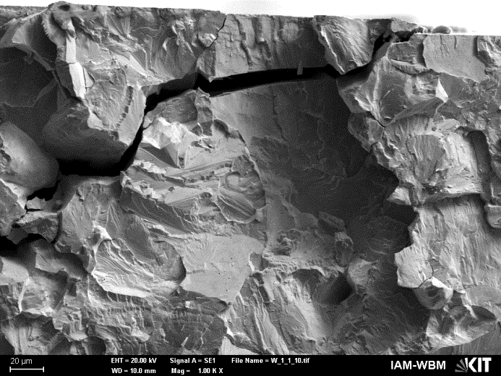

**(a)**

**(b)**

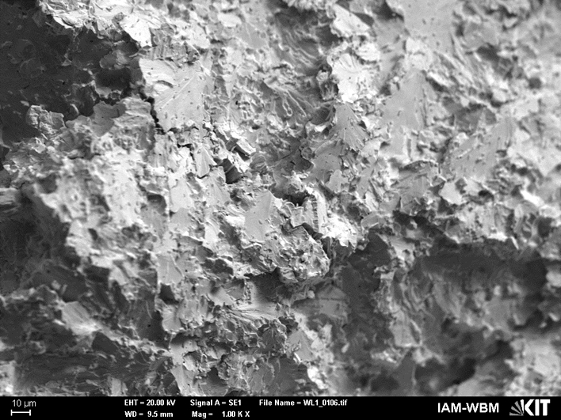

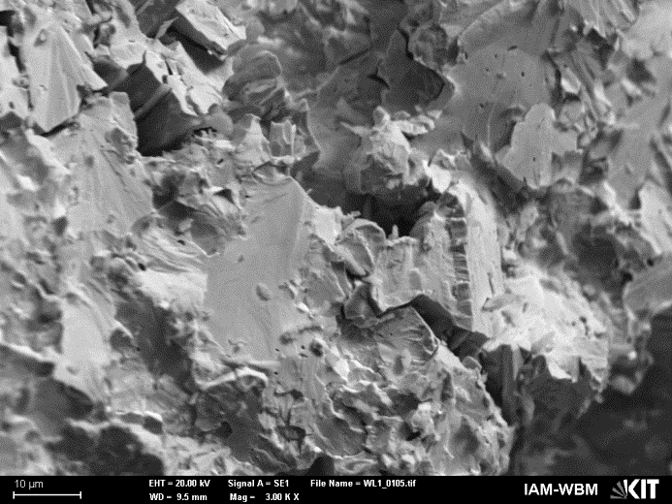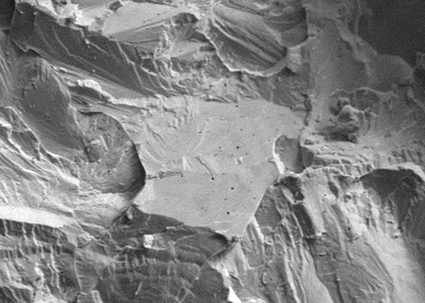

**(c)**

**(d)**

Figure 43: Fracture surface of bending specimens in longitudinal orientation of pure W (a) and WL10 (b). Cleavage fracture and assumed sinter pores within grains are highlighted.

Figure 4 shows the fracture surfaces of bending specimens in longitudinal orientation of pure W (a) and WL10 (b). All fracture surfaces, tested at RT, indicates cleavage fracture and transgranular fracture with no noticeable macroscopic plastic deformation. In minor cases appearance of intergranular fracture is observed too. Sinter pores are located within the grains of pure W (c) and WL10 (d) which appears to come from powder metallurgy fabrication process.

## FEM – Cohesive Zone Elements

The brittle crack propagation was modelled with a cohesive zone model with a traction separation law (TSL) of Needleman [9] embedded as a user element in the FE simulation software Abaqus®. A 2d model of the SENB fracture mechanic specimen with cohesive zone elements in the notch plane was developed to describe the crack propagation along the plain of the notch root. Additionally, a 4PB specimen was modelled to obtain stress distribution data for post processing with STAU.

### Elastic Properties and Cohesive Zone Parameters

Young`s modulus and the Poisson`s ratio are material parameters for the linear elastic simulation in the 2d and 3d model as well. The separation behaviour of cohesive elements is described by the traction-separation law of Needleman with the cohesive stress and cohesive energy. The cohesive zone parameters, listed in table 3, were selected based on tensile data and fracture mechanic data of [10]:

Table 3: Elastic properties and cohesive zone Parameters considered for 2d fracture mechanical specimen.

|  |  |  |  |
| --- | --- | --- | --- |
| **E** | **** |  | **Г0** |
| **(GPa)** | **(-)** | **(MPa)** | **(Nmm-1)** |
|  |  |  |  |
| 410 | 0.28 | 1360 | 0.32 - 0.505 |
| 410 | 0.28 | 1500 | 0.32 -0.505 |

### 2d 3PB Model

The notched 2d 3PB specimen was modelled and illustrated in figure 5. The model consists of a fracture mechanic specimen with continuum elements, the support and loading pins as rigid bodies. All pins have a degree of freedom in the z axis and are connected with the specimen using hard contact. The FE mesh consists of linear quadratic elements (CS4) with 4 nodes. Next to the notch and the process zone, the mesh was refined. According to [3], the specimens in transverse orientations have a primarily intergranular and flat fracture surface. The main crack propagation was along the plain of the notch root; and therefore, 300 cohesive zone elements, with a length of 8 µm were embedded in the notch layer (highlighted in red). Further convergence study with variation of cohesive elements length will follow.

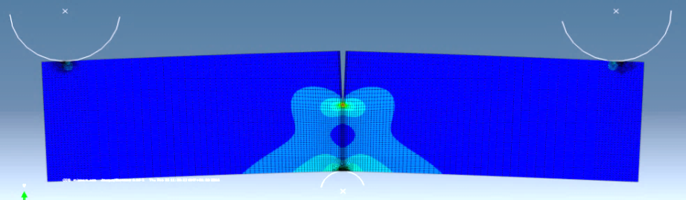

Figure 5: Stress distribution in 2d 3PB specimen after 0.1 mm deflection in Abaqus®.

Figure 6 shows the load-displacement curves of 3PB model with CZE embedded in the notch plane with two different maximum cohesive stresses (1360 and 1500 MPa) and maximum cohesive energies (0.32 – 0.5 Nmm-1). The load drop after reaching maximum load represents the failure of the first cohesive elements in the vicinity to the notch. The influence of the cohesive stress is negligible in comparison to the cohesive energy.



Figure 6: -displacement curves of 3PB model with CZ elements embedded in the notch plane and experimental data of pure W with = 16.26 MPa m0.5.

The calculated values of crack growth simulation at RT and experimental values in weak orientations are listed in table 4. The results of crack growth simulation with CZ elements in the notch plane are comparable with fracture toughness of pure W [10], [11] in weak orientation with the respect to the loading direction of the specimen.

Table 4: and calculated of crack growth simulation at RT and experimental values in weak orientations given in [10], [11].

|  |  |  |
| --- | --- | --- |
|  |  | / |
|  |  |  |
| 1500 | 97 | 4.28 |
| 166 | 7.34 |
| 246 | 10.85 |
| 317 | 13.98 |
| 1360 | 148 | 6.51 |
| 244 | 10.78 |
| 301 | 13.26 |
| 318 | 14.04 |
| W_R-L [10] | - | 8.10 |
| W_C-R (10] | - | 8.40 |
| W [11] | - | 7.00 |

### 3d 4PB model

The 2d 4PB model was modelled to calculate the stress distribution within the specimen and to obtain stress data for post processing failure probability of W and WL10. The main contact parameters and mesh as well as the material properties of the model are similar to the 3PB model. The FE mesh consists of linear quadratic elements with four nodes either in the plane strain (CES4) or in the plane stress (CPS4) condition.



Figure 7: Bending stress-deflection curves of experiments and simulation.

The bending stress-deflection curves in figure 7 show the simulation with plane stress condition (blue dotted) and plane strain condition (green dotted) of the 2d model. Both conditions are simulating the extreme constraint situation at the surface or in the specimen within a 3d model. Therefore, the stress-deflection curve of a simulation with a 3d model is between both curves. However, further analysis and changing of model and contact parameter have to be performed to optimize simulation results.

# Irradiation experiments

Irradiation experiments have to be done to investigate the irradiation effects on tungsten alloys and other EUROFUSION baseline materials for the later long-term use in fusion reactors. Due to the high cost of irradiation and the problematic nuclear waste disposal the total specimen volume has to be as small as possible. However the size constraints for (fracture) mechanical test have to be fulfilled to get reliable results which are transferrable to regular component size and stress distribution. Especially the probabilistic failure analysis of brittle material with a common specimen numbers is not feasible within a irradiation program [12]. Therefore the extent of scatter of tungsten alloys dependent on temperature in the (semi) brittle regime, on texture and failure possibility due to specimen volume has to be investigating first on non-irradiation specimens sufficiently to suggest proper irradiation experiments. With the successful application of the probabilistic approach the number of specimens and orientations can be reduced. Afterwards irradiation experiments with smaller bending specimens, considering the influence of the specimen volume on the failure probability, can be conducted.

# Conclusion and Outlook

## Conclusion

All pure W bending specimens in longitudinal orientation primarily failed at RT by a brittle manner. The mean maximum flexural strength is 731 ± 74 MPa. No macroscopic plastic deformation is noticeable. On the contrary WL10 shows consistent bending deformation after testing with fragmentation in several pieces. Primarily cleavage and transgranular fracture was observed in fracture surface analysis for both materials.

Fracture toughness of pure W in rod and sheet form is comparable with literature data. Due to blunting of notches, the fracture toughness of WL10, tested at elevated temperatures, don’t fulfill the size requirements and are hence invalid. The notch preparation has to be optimized as well to ensure crack initiation in the notch plane and high stress triaxiality in the notch ground. Nevertheless more tests have to be conducted to obtain a reliable database in the whole temperature range. The failure of a control unit of the universal testing machine and a time-consuming specimen production led to a delay of the (fracture-) mechanical experiments. Therefore, no further probabilistic failure analysis, based on experimentally determined Weibull parameters, could be performed.

The crack growth simulation with Abaqus**®** and embedded cohesive zone elements can describe the crack initiation of W in weak orientation at RT. The fracture toughness values, based on the simulation, are comparable to pure W in the weak orientation given in [10], [11]. In addition to describe crack propagation in the strong orientation cohesive zone elements have to be embedded perpendicular to the notch plane. Further optimization, better parameter identification as well as a convergence study of CZE lengths would lead to improved compliance of simulation and experiment. A few reasons for the deviation could be blunting effects at the notches in the experiments and the missing influence of stress multiaxiality in the 2d model. The identification of cohesive parameters has not been executed completely yet due to the lack of experimental force-deflection data of bending and fracture mechanical tests at all temperatures in the brittle regime. Hence a comprehensive comparison of experimental data and crack growth simulation and the verification of the crack growth model have not been performed yet.

## Outlook

Additional fracture mechanical tests in the temperature range of RT up to 300°C will be performed in 2017 in order to generate database and to validate the developed damage model. As well as the 4PB tests supporting the probabilistic Weibull analysis in the same temperature range are going to continue in 2017.

The crack growth modelling of rolled W and WL10 will be continued in 2017. To describe the crack growth behaviour of tungsten in the strong as well as the weak orientation, cohesive zone elements will be embedded horizontal and vertical direction within the process zone.

# References

[1] J. Aktaa, “Report for WP13-DTM-03-T05 – Development of DEMO SDC-IC – Structural Design Criteria for W / W alloys,” 2013.

[2] M.Conte, “Report for WPMAT EDDI-1.3.1 T03 D1 - EDDI SDC – Priority Gaps – Brittle Fracture.” 2015.

[3] D. Rupp and S. M. Weygand, “Anisotropic fracture behaviour and brittle-to-ductile transition of polycrystalline tungsten,” *Philos. Mag.*, vol. 90, no. 30, pp. 4055–4069, Oct. 2010.

[4] ASTM Standard, “E399- 09: Standard Test Method for Linear-Elastic Plane-Strain Fracture Toughness KIc of Metallic Materials,” *Annu. B. ASTM Stand.*, p. 33, 2009.

[5] N. Holstein, W. Krauss, and J. Konys, “Development of novel tungsten processing technologies for electro-chemical machining (ECM) of plasma facing components,” *Fusion Eng. Des.*, vol. 86, no. 9–11, pp. 1611–1615, 2011.

[6] T. Nishida, Y. Hanaki, T. Nojima, and G. Pezzotti, “Measurement of Rising R-Curve Behavior in Toughened Silicon Nitride by Stable Crack Propagation in Bending,” *J. Am. Ceram. Soc.*, vol. 78, no. 11, pp. 3113–3116, 1995.

[7] ASTM C1161-13, “Standard Test Method for Flexural Strength of Advanced Ceramics at Ambient,” *Annu. B. ASTM Stand.*, vol. 11, pp. 1–16, 2008.

[8] T. Weber, M. Härtelt, and J. Aktaa, “Considering brittleness of tungsten in failure analysis of helium-cooled divertor components with functionally graded tungsten/EUROFER97 joints,” *Eng. Fract. Mech.*, vol. 100, pp. 63–75, Mar. 2013.

[9] A. Needleman, “A continuum model for void nucleation by inclusion debonding,” *J. Appl. Mech.*, vol. 54, no. 3, p. 525, 1987.

[10] E. Gaganidze, D. Rupp, and J. Aktaa, “Fracture behaviour of polycrystalline tungsten,” *J. Nucl. Mater.*, vol. 446, no. 1–3, pp. 240–245, Mar. 2014.

[11] D. Rupp and S. M. Weygand, “Experimental investigation of the fracture toughness of polycrystalline tungsten in the brittle and semi-brittle regime,” *J. Nucl. Mater.*, vol. 386–388, pp. 591–593, Apr. 2009.

[12] ASTM C1239-13, “Standard Practice for Reporting Uniaxial Strength Data and Estimating Weibull Distribution Parameters for Advanced Ceramics,” *Annu. B. ASTM Stand.*, pp. 1–17, 2000.

1. One *Deliverable Report* shall be submitted for each deliverable e.g. Study Report, Commissioning Report, Final Assessment Report, Technical Acceptance Report, Procurement Report, etc.